Y8 DATA HANDLING PROJECT – THE NATIONAL LOTTERY

Activity 1 Aims:

Y8 NNS CORE
- Discuss a problem that can be addressed by statistical methods and identify related questions to explore.
- Decide which data to collect to answer a question, and the degree of accuracy needed; identify possible sources.
- Plan how to collect the data, including sample size; construct frequency tables with given class intervals.
- Collect data using a suitable method.
- Construct, on paper and using ICT:
- Pie charts
- Bar charts and frequency diagrams
- Simple line graphs for time series
- Simple scatter graphs
Identify which are most useful in the context of the problem.
- Interpret tables, graphs and diagrams and draw inferences that relate to the problem being discussed; relate summarised data to the questions being explored.
- Communicate orally and on paper the results of a statistical enquiry and the methods used, using ICT as appropriate; justify the choice of what is presented.

Hypothesis 1: You can mathematically predict the winning numbers. The higher the ‘Set’ number, the higher the balls will be.

Resources: ‘Master’ spreadsheet (discussion only), ‘Set’ spreadsheets, Hypothesis 1 Collection sheets (optional), graph paper, lottery simulator, silly lottery facts.

1. Discuss the ‘Master’ spreadsheet – highlight key features such as machine, set of balls number, etc

2. Divide the class into groups and give each group a different set spreadsheet. Each group collects a random sample of winning lines (sample size discussion – 10% for each set number) using randomly generated numbers. Tally the frequency of each number in class intervals of 10.

E.g. Set 1

Class interval | Tally | Frequency
0 – 9
10 - 19
20 – 29
30 – 39
40 - 49

3. Use ICT/paper to interpret the results and draw conclusions.
Using your results, which 6 numbers would each group pick?

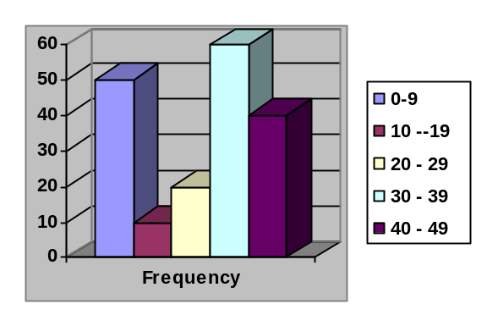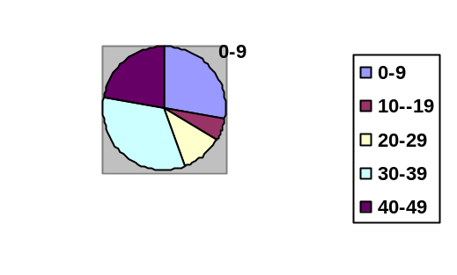

4. Ask each group to analyse their samples and select the 6 numbers that are most guaranteed to win the jackpot. Simulate the national lottery using ‘Lottery Simulation’ with their predicted winning numbers – emphasise their total loss. The lottery is a bad investment. Use the simulator to illustrate that you need around 57 goes to win £10 – i.e. congratulation you have lost £47!!!! Compare this with the LUCKY NUMBERS charts info in APPENDIX A.
- Blind the pupils with crazy facts surrounding the lottery.

Official Odds from National Lottery Literature
 | Odds
Matching Numbers | Lottery | Thunder ball | Extra
Match 6 | 1 : 13,983,816 |  | 1 : 13,983,816
Match 5+ | 1 : 2,330,636 | 1 : 3,895,584
Match 5 | 1 : 55,492 | 1 : 299,660.3
Match 4+ |  | 1 : 26,866.1
Match 4 | 1 : 1,033 | 1 : 2,066.6
Match 3+ |  | 1 : 959.5
Match 3 | 1 : 57 | 1 : 73.8
Match 2+ |  | 1 : 106.6
Match 1+ |  | 1 : 32.8

Crazy facts:

- Compare the 1 in 14 million odds of winning the lottery with:

Dying from ….. in any one year | Odds
Being struck by lightning | 1 in 10 million
Drowning in the bath | 1 in 800 000
Playing soccer | 1 in 25 000
In a plane crash | 1 in 20 000
An asteroid or comet hitting the Earth | 1 in 20 000
Being involved in a road accident | 1 in 8 000
Influenza | 1 in 5 000
Smoking 10 cigarettes a day | 1 in 200

- For every £1 paid into the lottery ,50p goes into the prize money, and the rest goes in tax, good causes and administration. That means your expected return on each bet is a loss of 50p!!! Everytime, you don’t play the lottery you have made a 50p profit!!!! – see ‘WHERE DOES YOUR MONEY GO?’ pie chart in APPENDIX A.
- Which day of the week should you buy a ticket for the Saturday lottery?
- If you buy it earlier than Friday, your chance of winning the jackpot is 1 in 13.9 million which is lower than the chance of being over by a car in a 2 day period – 1 in 10 million!! – i.e. you won’t be able to claim your prize!!!

- ONLY MUGS PLAY THE NATIONAL LOTTERY!! – 1 in 57 chance of winning £10 – hence, on average you lose £47 when you think you have won £10. How many people stop if they win £10? Scratch cards?
- Give amazing facts about the lotto!!
- lucky locations in APPENDIX A – misuse of data?!?
- unclaimed prizes
- number frequency – I told you 13 is unlucky!!!
- Silly facts

- Play the ‘nice lottery’ – still lose!!!

  - Compare the odds of the Irish Lottery using Pascal’s triangle.

  - Download – the Lottery Star Map – very pretty.

Activity 2 Aims:

- Y8 NNS Core:
Calculate statistics …..recognise when it is appropriate to use the range, mean, mode or median
Interpret graphs and diagrams and draw inferences that relate to the problem being discussed.
- Y8 NNS Extension:
Interpret graphs and diagrams and draw inferences to support or cast doubt on initial conjectures; have a basic understanding of correlation.
- Data Handling Coursework Preparation (655)

 | SPECIFY & PLAN | COLLECT, PROCESS & REPRESENT | INTERPRET & DISCUSS
4 | Hypothesis 1  The student has described clearly what s/he is going to do, how s/he is going to do it and their size of sample. Hypotheses stated. Data Collection 1 | The student has produced a scatter diagram of the first 30 sets of data – correctly drawn, plotted and labelled with only minor errors being condoned. | The student states ‘The positive/neghtaive correlation means that, on average, …’. Analysis 1
5 | Hypothesis 2  The student moves into a more complex line of enquiry – examine the relationship across the gender divide due to the first 30 being male dominated. | - The student adds a line of best fit to their scatter diagram - correctly drawn, with a ruler and not forced through the origin.  - Excel produced scatters for males, females and all 60.  - PMCC calculated  - All scatters contain lines of best fit, equations of lines of best fit and PMCC | - The student uses the line of best fit to estimate the weight of student 1.  - The student states ‘There is a positive correlation between height and weight in males and females and it is stronger in males than females’ or similar.  - The student uses the equations of the lines of best fit to calculate the weight of a male of height 1.45m. Considers female and mixed scenario.  - Comments on the growth rates of males and females. Analysis 2
6 | The student describes clearly what s/he is going to do, how s/he is going to do it and their use of random sampling.  Data Collection 2 | - Mean of grouped data calculated  - The student has constructed cf curves for height and weight, males and females.  - Medians estimated using cf curves  - Quartiles used to produce box and whisker diagrams | The student states ‘In general, boys are taller than girls because the median height for boys is greater than that for the girls’ or similar. Similar statement for the weight. Analysis 2
7 | - The student has described clearly the impact of any untypical results or outliers  - impact on the PMCC – recalculated  - impact on the mean – recalculated – and so median preferred.  - Student has commented on the uncertainty of their conclusions and suggested ways in which they might improve their strategy, such as sampling by age as well as gender. | The student has carried out an appropriate stratified sampling approach with the ten gender/year groups. | - ‘…..even though, on average, males are heavier and taller than females, analysing the box and whisker plots, I can see that x% of females are heavier/taller than the average male. Analysis 2  - The student comments on the scatter diagram conclusions to be only valid within the data range given. ‘Meaningless’ of the intercept of the line of best fit. Analysis 2

NOTE: SUPERB OUTLIERS ARE WEEK 9 (133 WINNERS!!) AND ANY IN BOLD – ‘SPECIAL’ GUARANTEED WINNING WEEKS

- Preparation task – Find the Scatterdiagram Buddy

Hypothesis 2: The higher the average of the 6 numbers, the higher the set number

NICE OPPORTUNITY TO DISCUSS WHICH AVERAGE IS THE MOST APPROPRIATE ONE TO USE

Use a random generator between 1 and 882 to select a random sample of 30 lines. Students construct a hand drawn scatterdiagram and comment on the correlations, identify any outliers and comment on the significance of the gradient and y-intercept.

Use ICT (class demo or individual) to analyse bigger samples (10% = 88 lines) to produce a scatterdiagram of average winning number vs set number.

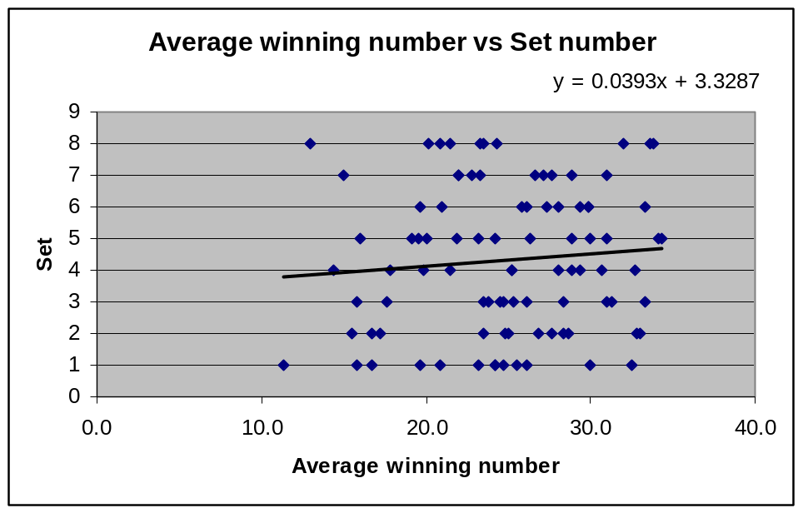
PMCC = 0.094451

Calculate regression values and analyse trend lines to draw conclusions.

(Slight positive correlation – the higher the average winning number, the higher the set number!!?!. Obviously, this is not right – discussion about outliers. Demonstrate the impact of outliers by recalculating the PMCC.)

POPULATION RESULT: PMCC = 0.012331

Hypothesis 3: The higher the average of the 6 numbers, the higher the total jackpot paid out by Camelot

Use a random generator between 1 and 882 to select a random sample of 30 lines. Students construct a hand drawn scatterdiagram and comment on the correlations, identify any outliers and comment on the significance of the gradient and y-intercept. (NOTE: BOLD FIGURES ARE GUARANTEED WEEKS)

Use ICT (class demo or individual) to analyse bigger samples (10% = 88 lines) to produce a scatterdiagram of average winning number vs set number.

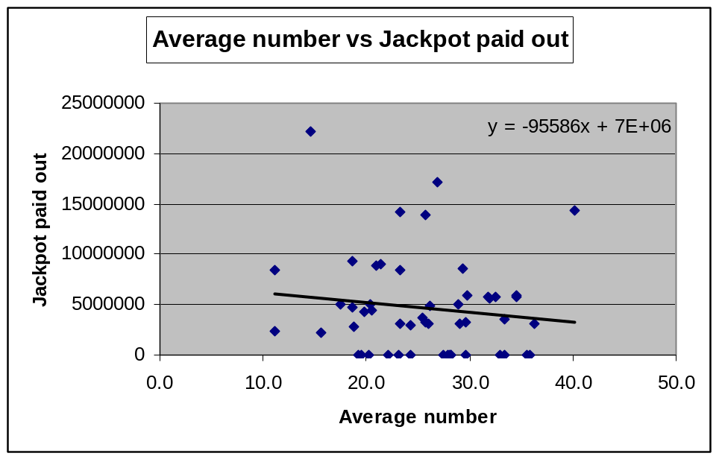
PMCC =
-0.12853
Calculate regression values and analyse trend lines to draw conclusions.

(Weak Negative correlation – the higher the average winning number, the lower the jackpot paid out. The gradient indicates that for every one increase in the average number, the total jackpot decreases by £95586!?!. The y-intercept is meaningless (0 winning number = jackpot of 7000000) because data range has to start at (6+5+4+3+2+1)/6 = 3.5.)

POPULATION RESULT: PMCC = -0.03338

Hypothesis 4: Most people use dates of birthdays as their 6 lottery numbers. You must always have a number higher than 32 to win a larger share of the Jackpot.
- The higher the average of the 6 numbers, the higher the jackpot winnings per person

Note: Samples including Week 9 will give nice discussion points

Use a random generator between 1 and 882 to select a random sample of 30 lines. Students construct a hand drawn scatterdiagram and comment on the correlations, identify any outliers and comment on the significance of the gradient and y-intercept.

Use ICT (class demo or individual) to analyse bigger samples (10% = 88 lines) to produce a scatterdiagram of average winning number vs set number.

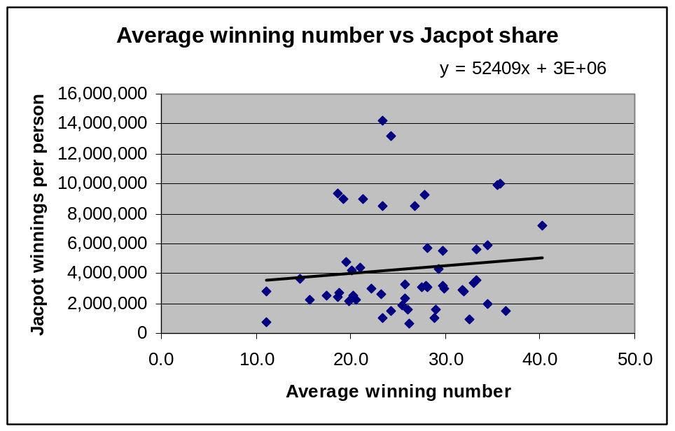
PMCC = 0.106164

Calculate regression values and analyse trend lines to draw conclusions.

(Weak Positive correlation – the higher the average winning number, the more money each person wins. The gradient indicates that for every one increase in the average number, the total money winnnings per person increases by £52409!?!. The y-intercept is meaningless (0 winning number = jackpot of 3000000) because data range has start at (6+5+4+3+2+1)/6 = 3.5. The trend line can be used to calculate the difference in winnings in someone who has an average winning number of 20 compared to an average winning number of 40 – almost £1 000 000 difference!!!!)

POPULATION RESULT: PMCC = 0.240524

Hypothesis 5: The higher the average of the 6 numbers, the more winners

Hypothesis 6: The total sum should be distributed normally about 150 (6x25).

Interesting Articles

- Teaching Mathematics through National Lotteries

- Lottery Guides - Calculating the Odds

- How to win the National Lottery – Peter Stirling

APPENDIX A
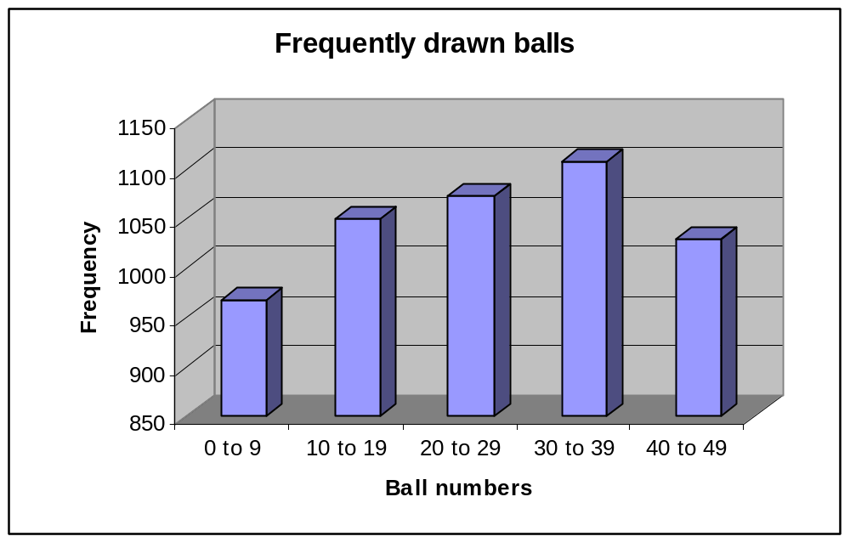
Source: www.national-lottery.co.uk – results up to June 2004
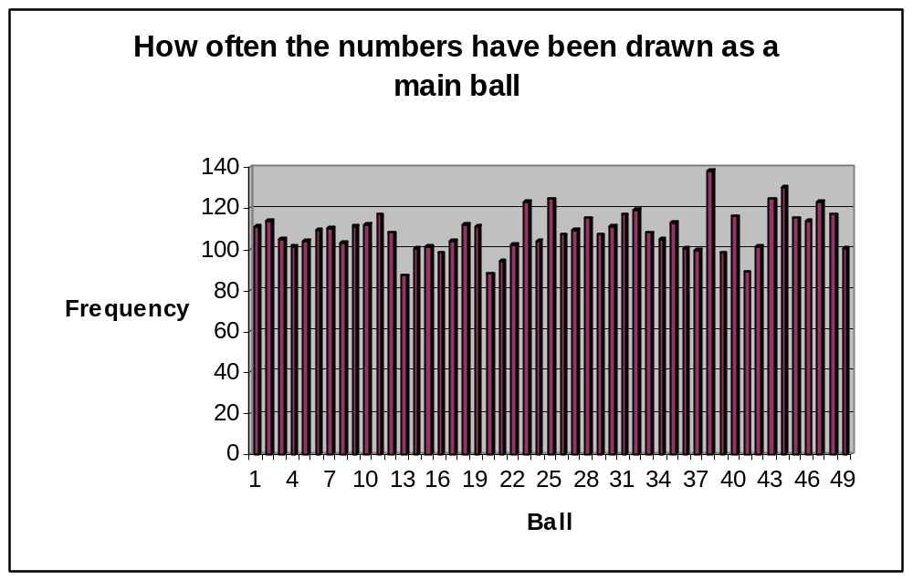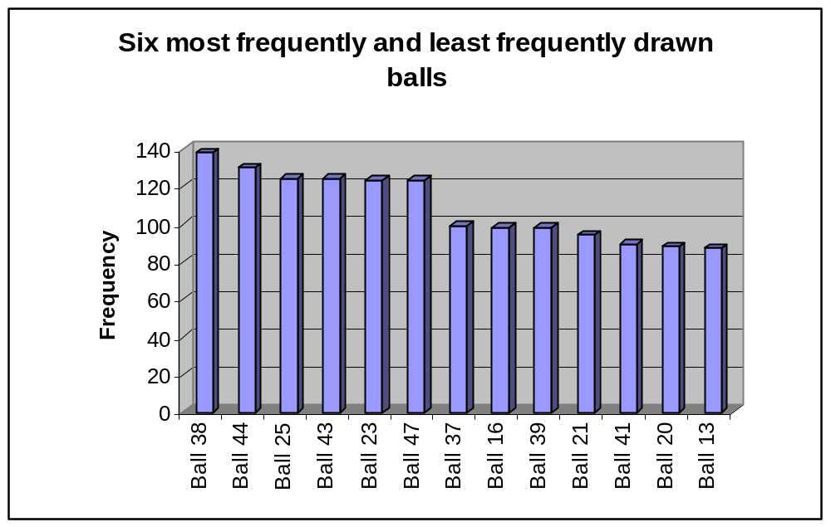
Source: www.national-lottery.co.uk – results up to June 2004
Source: www.national-lottery.co.uk – results up to June 2004
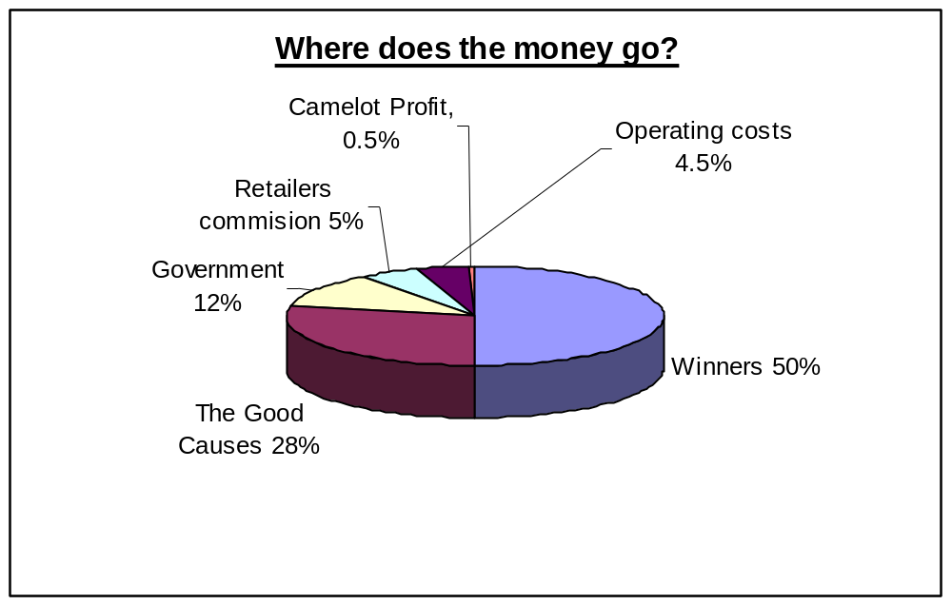
Source: www.national-lottery.co.uk – results up to June 2004

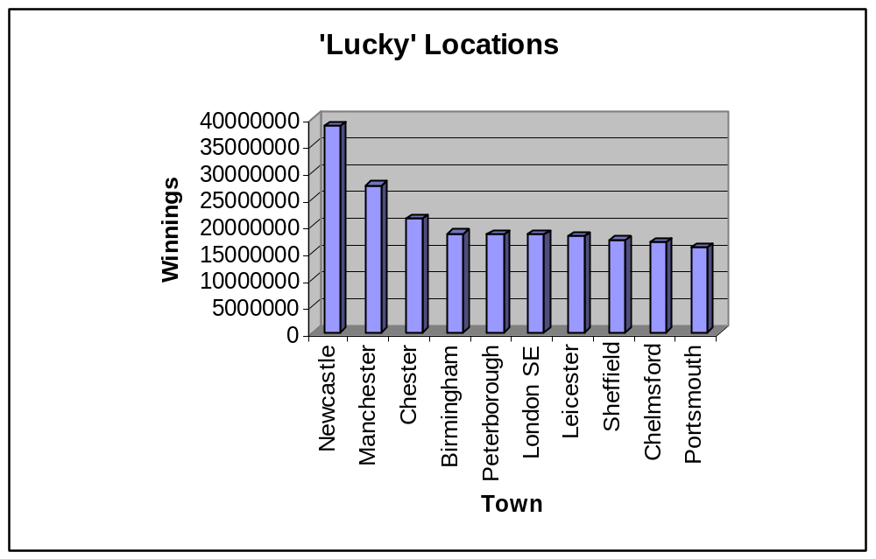
Source: www.national-lottery.co.uk – results for 2003

